Slurred or Imprecise Diction

😶‍🌫️ What is Slurred or Imprecise Diction
# Source: AI Source: Provided by: [Data Path: Persons Table -> ID Column: 1, Name_En Column: Motasem Essam] -> From: [Chatgpt (GPT-4-turbo)] on [7/30/2025]
Slurred or imprecise diction refers to unclear or muddled pronunciation of words, often caused by laziness in articulation, regional habits, or lack of speech clarity. It makes speech difficult to understand and is typically viewed as a communication flaw in formal settings.

✅ Key Features:
# Source: AI Source: Provided by: [Data Path: Persons Table -> ID Column: 1, Name_En Column: Motasem Essam] -> From: [Chatgpt (GPT-4-turbo)] on [7/30/2025]
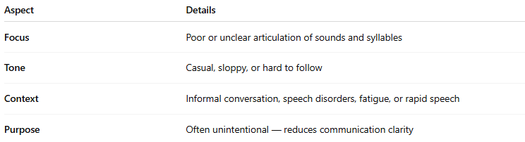
Aspect | Details
Focus | Poor or unclear articulation of sounds and syllables
Tone | Casual, sloppy, or hard to follow
Context | Informal conversation, speech disorders, fatigue, or rapid speech
Purpose | Often unintentional — reduces communication clarity

⚠️ Common Causes of Slurred/Imprecise Diction:
# Source: AI Source: Provided by: [Data Path: Persons Table -> ID Column: 1, Name_En Column: Motasem Essam] -> From: [Chatgpt (GPT-4-turbo)] on [7/30/2025]
- Speaking too quickly or too softly
- Dropping syllables or final sounds
- Regional dialects or accents
- Fatigue or intoxication
- Speech motor control issues

🧠 Examples of Slurred or Imprecise Diction:
# Source: AI Source: Provided by: [Data Path: Persons Table -> ID Column: 1, Name_En Column: Motasem Essam] -> From: [Chatgpt (GPT-4-turbo)] on [7/30/2025]
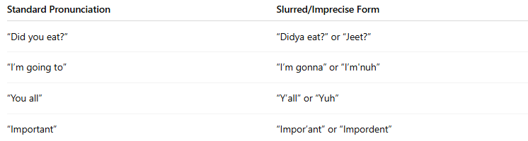
Standard Pronunciation | Slurred/Imprecise Form
“Did you eat?” | “Didya eat?” or “Jeet?”
“I’m going to” | “I’m gonna” or “I’m'nuh”
“You all” | “Y’all” or “Yuh”
“Important” | “Impor’ant” or “Impordent”

🎙️ Speech Example:
# Source: AI Source: Provided by: [Data Path: Persons Table -> ID Column: 1, Name_En Column: Motasem Essam] -> From: [Chatgpt (GPT-4-turbo)] on [7/30/2025]
- Clear: “I did not understand what she was saying.”
- Slurred: “I dunno wha’ she wuz sayin’.”

🆚 Slurred Diction vs Clear Diction:
# Source: AI Source: Provided by: [Data Path: Persons Table -> ID Column: 1, Name_En Column: Motasem Essam] -> From: [Chatgpt (GPT-4-turbo)] on [7/30/2025]
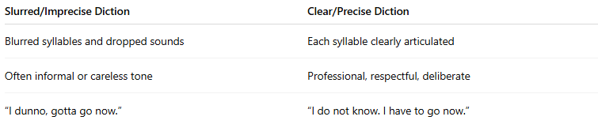
Slurred/Imprecise Diction | Clear/Precise Diction
Blurred syllables and dropped sounds | Each syllable clearly articulated
Often informal or careless tone | Professional, respectful, deliberate
“I dunno, gotta go now.” | “I do not know. I have to go now.”

🧭 Common in:
# Source: AI Source: Provided by: [Data Path: Persons Table -> ID Column: 1, Name_En Column: Motasem Essam] -> From: [Chatgpt (GPT-4-turbo)] on [7/30/2025]
- Casual conversation
- Regional dialects
- Unrehearsed or fast speech
- Younger speakers or informal groups

❗Note:
# Source: AI Source: Provided by: [Data Path: Persons Table -> ID Column: 1, Name_En Column: Motasem Essam] -> From: [Chatgpt (GPT-4-turbo)] on [7/30/2025]
Slurred diction is not always incorrect—it may reflect natural speech in informal settings, dialects, or creative writing (e.g., character dialogue in fiction). However, in formal speech, education, or public communication, clear diction is preferred.

